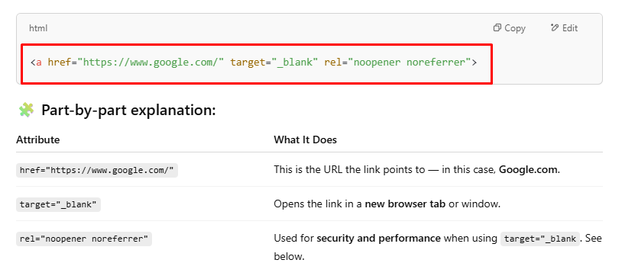

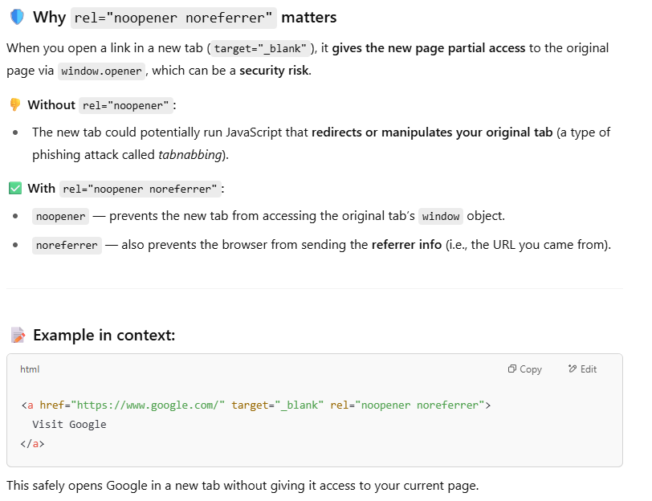

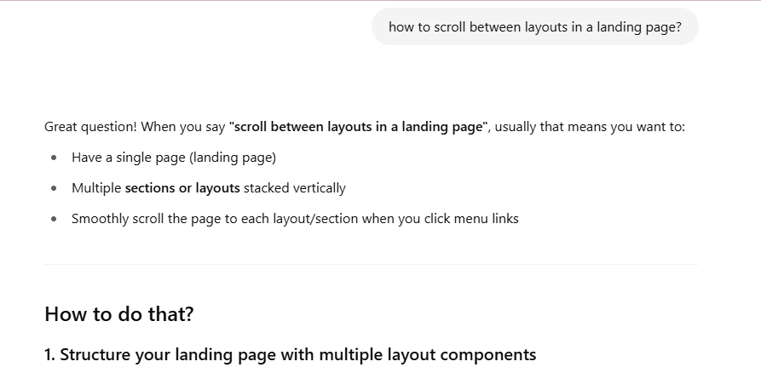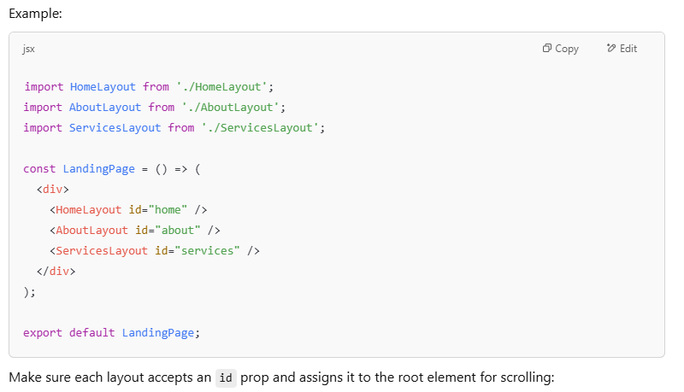

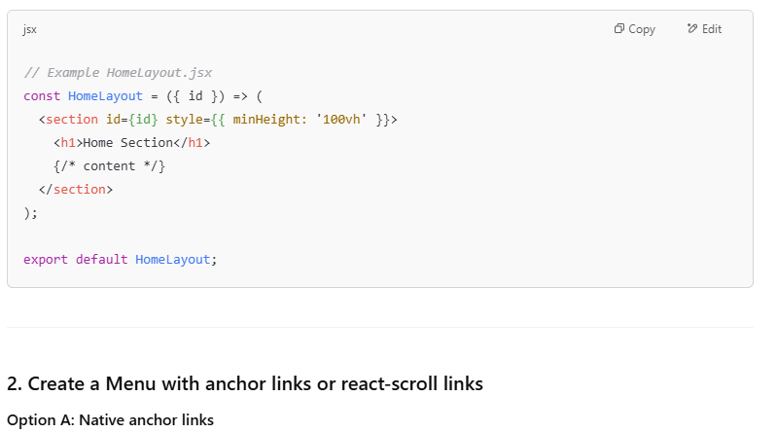

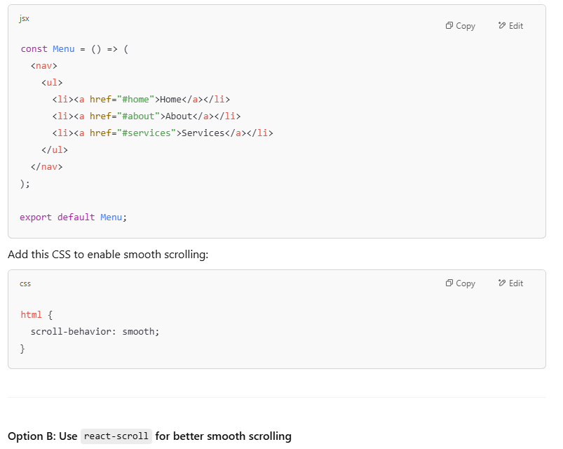

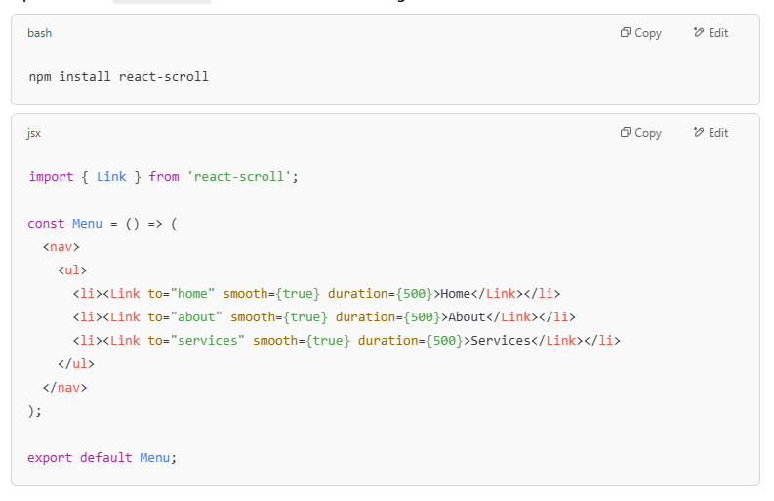

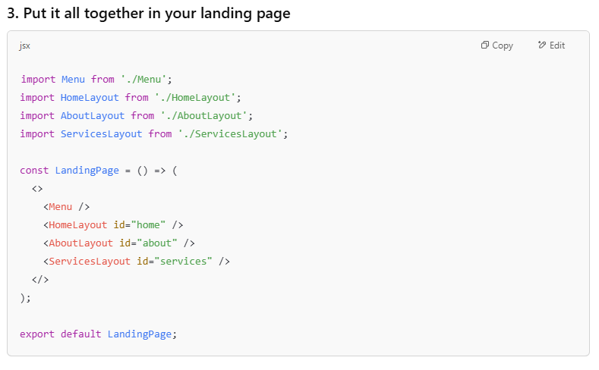

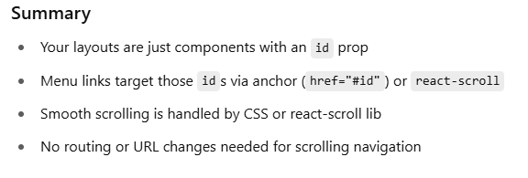

Continuous Learning, Skill Growth, Team Collaboration, Frontend Innovation, Technical Excellence, Professional Development" can you include all those key words 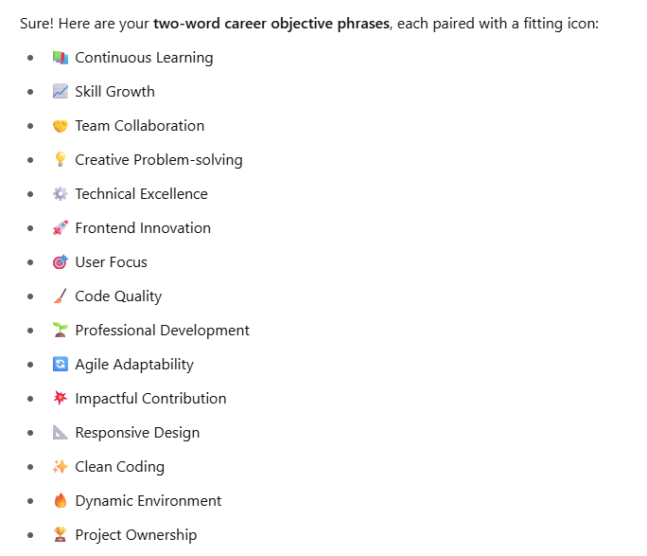

<https://chatgpt.com/c/68389658-a29c-800d-8074-7ba905557741>

About Me (Short Version)

I'm Rubiya Yasmin, a frontend web developer with a PhD in Computer Science. Though new to the industry, I bring strong technical skills in React, Redux, SASS, and responsive design — along with a deep appreciation for clean, well-documented code. I'm eager to contribute to meaningful projects and continue growing as a developer.

Hi, I’m Rubiya Yasmin — a frontend web developer with a PhD in Computer Science and a passion for clean code and clear documentation. I bring a strong academic foundation and hands-on skills in React, Redux, SASS, Tailwind CSS and responsive web development. I focus on building user-friendly, accessible, and scalable interfaces that combine thoughtful structure with visual clarity.

I'm excited to grow as a developer and contribute to meaningful, user-centered projects — and to keep learning, building, and growing along the way.

Aspiring Frontend Developer | Clean Code & Modern UI | React, Git, Tailwind

Aspiring Frontend Developer | React · Redux · SASS · Git · Responsive Design

**Career Objective**

I am a frontend developer with a PhD in Computer Science, passionate about turning ideas into clean, responsive websites. Skilled in React, Redux, SASS, Tailwind CSS, and Git, I aim to join a team where I can grow, learn, and create user-friendly web experiences with clear, maintainable code.

**Career Objective**

Motivated and detail-oriented frontend web developer with a PhD in Computer Science, seeking to leverage strong skills in React, Redux, SASS, Tailwind CSS, and Git to build responsive, user-centric web applications. Eager to contribute to a dynamic development team, apply academic knowledge to practical challenges, and grow as a professional through hands-on experience and continuous learning.

